

FortnaPlus Control
Print and Apply
Operator’s Screen
Document Revision: 1.1
Date: 02-Feb-2023

Revision | Date | Author | Revision Summary
1.0 | 01-Mar-2013 | Unknown | New document
1.1 | 02-Feb-2023 | T R Kremser | Update and general refresh

Table of Contents
Glossary of Terms 4
1. Print and Apply Module 5
2. Operator’s Screen 5
3. PNA Printer Options Window 8
4. Recovering From PNA Error Conditions 10
4.1. Single Printer Error 10
4.2. Halted Conveyor Error 11
5. Printer Maintenance 12

Confidential/Proprietary Statement
This document contains trade secrets and information that is considered confidential and proprietary to Fortna, Inc. It may not be duplicated, used, or disclosed outside the original recipient organization, and it may not be duplicated, in whole or in part, for any purpose other than to evaluate this document. Fortna Material Handling reserves the right to modify this document as necessary to reflect any terms and conditions negotiated and included as part of a subsequent contract or purchase order.

Glossary of Terms
AC – Automation Controller
FPC – FortnaPlus Control
PNA – Print and Apply
UPS – Uninterruptible Power Supply

Print and Apply Module
The FortnaPlus Control Print and Apply Module features advanced print-and-apply functionality including:
- Automatic printer management supporting redundant printers for maximum throughput and for continued operation while printers are serviced.
- Printers can be automatically disabled if errors are detected, or for consecutive verification errors. Any remaining printers for the same label type will continue to operate.
- Automatic line halt when no printers are available for a given label type.
- Automatic line halt for containers that are too large or too small.
This document describes the Operator’s interface screen and its effective use for normal operation and for error recovery.

Operator’s Screen
The Print and Apply Operator’s screen is found at Operator Menu | Print Apply Status. All the controls necessary for operation of the print-and-apply line and for error recovery are present on or accessible from this screen.
Also see the FPC-PNA-Print-Apply-Configuration and FPC-PNA-ConfigurationChecklist documents.
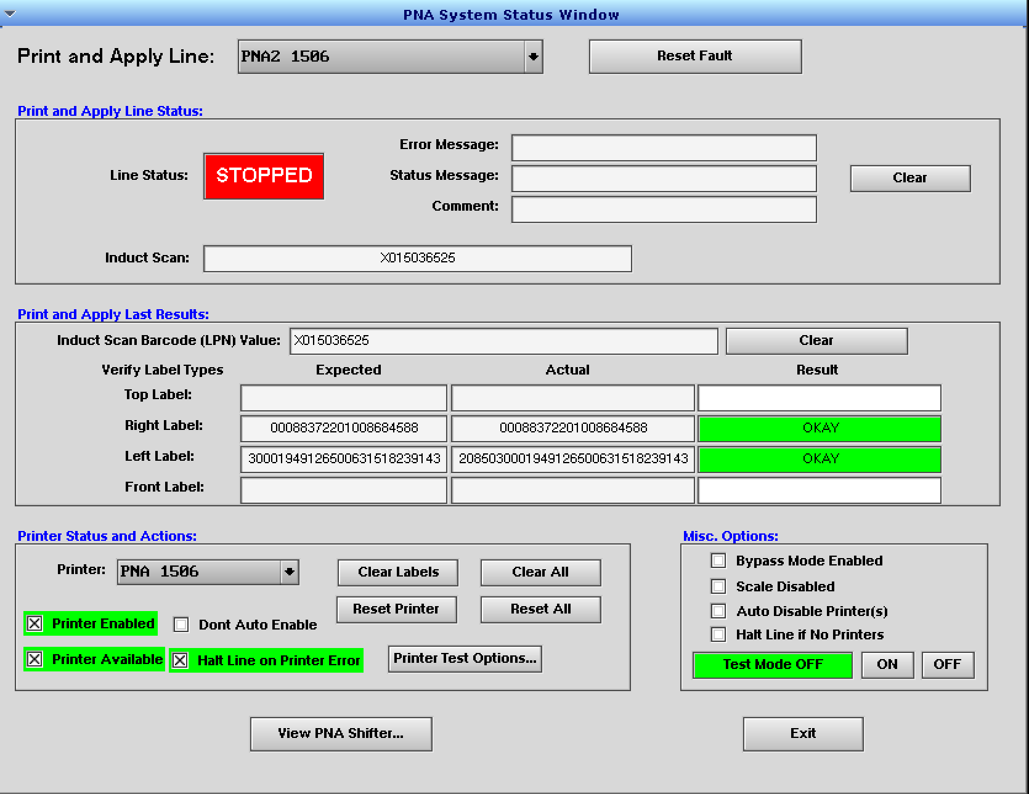

The individual elements of the screen are described below:
Operator’s Screen Details
Screen Element | Description
Print and Apply Line | This drop-down box shows the currently selected PNA line. One AC can be configured to control more than one line. Select the desired line using this control.
Reset Fault | This button is used to reset an active fault for the PNA line. All active printer errors are cleared. If the error caused the line to stop, it will restart when this button is clicked.
Print Apply Line Status | This block contains status information for the PNA line as a whole.  Line Status is linked to Encoders_EnableBit and will reflect its state, showing STOPPED or RUNNING.  Error Message, Status Message and Comment show the latest messages raised by the software, if any.  The Induct Scan box shows the last scan received at the induction scanner.  The Clear button will clear the three message fields and the Induct Scan box.
Print and Apply Last Results | This block displays verification results for the most recent container.  Induct Scan Barcode (LPN) Value shows the induct scan associated with the verification result.  The table of fields in the rest of this block show details of the verification for up to four label types:  - The Expected column shows the verification string required, as found in the LRM message response.  - The Actual column shows the scans from the newly-applied labels.  - The Result column shows the color-coded result of the comparison between the Expected and Actual strings. It can take the values: OKAY, MISMATCH, ERROR, or SCAN ERROR.  The Clear button clears the fields in this block.  Note that the Verify Label Types names are configurable to best describe each label in the context of a particular PNA configuration, so the names will vary.
Printer Status and Actions | This block contains controls for individual printers on the line.  Use the Printer pull-down to select the printer to work with.  The Printer Enabled checkbox shows the current enable status for this printer. A printer must be enabled so it can print labels. If a printer is disabled while labels are in process, they will not complete. Disabling a printer allows the PNA module to ignore that printer’s error signals so the line can run without it. If the auto error-handling feature is enabled (Auto Disable Printer(s)), it will control the state of this checkbox.  The Printer Available checkbox shows whether this printer is available to accept labeling tasks. Containers that are in-process when this is turned off will complete. If the auto error-handling feature is enabled (Auto Disable Printer(s)), it will control the state of this checkbox.  When Auto Disable Printer(s) is not in use, to disable a printer for servicing, first uncheck Printer Available, then wait for in-process containers to pass through, then uncheck Printer Enabled. Reverse this process to re-enable the printer.  The Don’t Auto Enable checkbox can be selected to prevent a printer from being automatically enabled when Auto Disable Printer(s) is in use. This is useful to take a printer offline for service.  The Halt Line on Printer Error checkbox controls how the line will respond when a printer error is detected. This should usually be checked.  The Clear Labels button will purge labels from the FPC label queue and the printer’s buffer for the selected printer. Note that if a label has already been printed, it must be manually removed from the tamp.  The Reset Printer button resets printer errors for the selected printer.  The Clear All button purges labels for all printers, just like selecting each printer and clicking its Clear Labels button. BE SURE that you want to clear all labels in queue for the line for ALL PRINTERS! We have disabled this button on many sites because it often does more harm than good!  The Reset All button resets printer errors for all printers, just like selecting each printer and clicking its Reset Printer button. This is generally OK to do, as it will have no ill effect on printers that have no errors.  The Printer Test Options button opens an additional dialog box (see below) that can be used to assist with debugging printer issues.
Misc Options | This block contains other control options that are useful for operation of a PNA line.  Bypass Mode Enabled – Use this to control and observe the status of bypass mode. While in bypass mode, containers pass through the PNA line without receiving labels or being subject to verification requirements.  Scale Disabled – Use this checkbox to disable the weight check requirement and allow the PNA line to operate without it.  Auto Disable Printer(s) – Use this checkbox to control the auto error-handling feature. It is linked to PrintApplyLine_AutoErrHandling. When on, printers will automatically be disabled when error conditions are detected. When the printer fault has cleared, the printer will automatically be re-enabled. If the line had been stopped because no printer was available for a given label type, it will restart when the printer is re-enabled, as well. While active, the Printer Enabled and Printer Available checkboxes are controlled by this feature.  Halt Line if No Printers – When this option is active, if all printers for a given label type are disabled the line will stop automatically.  Test Mode – Any container placed on the line while Test Mode is ON will receive test labels. Use this to verify the PNA line hardware is functional without need for interaction with the PandA engine messages. Set to OFF for normal operation.
View PNA Shifter | This button opens the graphical shifter window. Use it to view containers on the PNA shifters for diagnostic purposes.
Exit | Exit the Operator’s Screen.
Note that the controls on the Operator’s Screen have security settings, so they can be enabled or disabled for individual users, as needed.

PNA Printer Options Window
The Printer Test Options button on the Operator’s Screen opens the PNA Printer Options Window. This dialog box can be helpful when diagnosing printer problems.
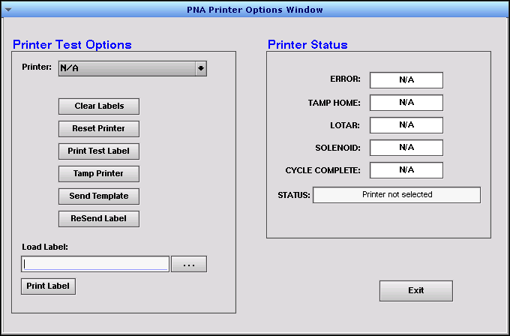

Operator’s Screen Details
Screen Element | Description
Printer Test Options | Use the buttons in this block to take actions on a specific printer to aid in recovery from errors or to help diagnose problems.  - Use the Printer pull-down to choose the printer to act upon.  - The Clear Labels button clears any queued labels in the printer’s memory that have not yet been printed, the same as the equivalent button on the Operator’s Screen.  - The Reset Printer button clears printer errors for the printer, the same as the equivalent button on the Operator’s Screen.  - The Print Test Label button sends the label of type Test Label from table LabelTemplates for this printer (if defined).  - The Tamp Printer button fires the tamp signal for this printer.  - The Send Template button send the label of type Template from table LabelTemplates for this printer (if defined).  - The ReSend Label button sends the most recently queued label in the send queue to this printer again.  - The Load Label box lets you specify any arbitrary file to send to this printer. They usually expect ZPL files. Use the ellipsis button to open a file selection dialog or type the file name directly into the box. If you do not specify a complete path, it assumes you are starting from the RUN directory.  - Use the Print Label button to send the label file selected in Load Label to the printer.
Printer Status | The fields in this block show the status of hardware signals associated with this printer.  - ERROR – The printer’s error signal.  - TAMP HOME – The printer’s tamp home signal.  - LOTAR – The “Label On Tamp And Ready” signal for this printer.  - SOLENOID – The output that fires the tamp.  - CYCLE COMPLETE – The input from the that indicates the tamp cycle has completed.  - STATUS – Messages from the PNA module.
Exit | Exit this screen

Recovering From PNA Error Conditions
Follow the steps listed in this section to properly recover from PNA error conditions.
When more than one printer is defined for the same label type, the printers will be used in round-robin fashion to distribute the workload and increase the throughput of the line. If a printer reports an error, it is removed from the list and the remaining printer(s) will handle the work. If all printers for a given label type are disabled, the line will halt.

Single Printer Error
Printers may be disabled for many reasons:
- Label stock has been exhausted.
- Print engine or applicator errors.
- The printer front cover has been opened.
- The printer has lost power or network connectivity.
- A container has reached the printer’s tamp point, but a label is not on the tamp head (LOTAR failure).
- Consecutive verification failures for labels from a particular printer.
When any of these conditions occur, the affected printer will automatically be disabled. It will not be considered for label printing assignment until the error condition has been corrected.
It is likely that there will be containers in process on the line that have had their labels assigned to the disabled printer. There is no mechanism for reassigning them to the remaining printer(s). When they reach the Wait update point, the line will pause for the configured time to wait for the label. When the label fails to appear, the line will restart. The container will fail verification and will be routed to exception handling.
Once the error condition has been resolved, follow these steps in the order shown to recover:
- Select the faulted printer on the Operator’s Screen.
- Click the Clear Labels button. Any queued labels will be discarded.
- Check the printer’s tamp head. If a label is present, remove it. Press the Apply button on the printer’s touchscreen to cycle the tamp mechanism. If another label is printed, remove it, and repeat until no more labels are printed. The printer’s label queue is now empty.
- Click the Reset Printer button to re-enable it for label assignment.

Halted Conveyor Error
Many conditions could cause a PNA line to halt, including:
- All printers for a given label type have been disabled.
- A container has failed sizing verification.
To recover from a halted PNA line, follow these steps in the order shown:
- Remove any containers on the belt that are between the induction photoeye and the printers. Containers that have labels already applied can be left on the belt.
- Click the Clear All button.
- Check the tamp heads for each printer. If a label is present, remove it. Press the Apply button on the printer’s touchscreen to cycle the tamp mechanism. If another label is printed, remove it, and repeat until no more labels are printed. The printer’s label queue is now empty.
- Verify that it is physically safe to start the line.
- Click the Reset All button.

Printer Maintenance
When redundant printers are in use, it is possible to perform routine maintenance on one of the printers, such as replenishing label stock or ribbon, while the line continues to run with the other printer(s). Follow these steps to avoid disruption:
- Uncheck Printer Available. This removes the printer from the list of printers that can receive label assignments. All new label assignments will be made to the other printer(s).
- Wait for containers between the induction scanner and the printer to pass through the line.
- Uncheck Printer Enabled. This will cause FPC to ignore any printer error signals from this printer while the work is performed.
- Perform the printer maintenance. Be sure to close all covers and restore the printer to a serviceable state before proceeding.
- Check the Printer Enabled checkbox. Printer error signals will again be honored.
- Check the Printer Available checkbox. The printer is returned to service and can accept new label printing assignments.

